**The UDP Bandmap**

Aki Yoshida JA1NLX

If you want callsign lookup when clicking directly on WSJT/JTDX then check “Enable callsign lookup when clicking on WSJT/JTDX”.

If you want to send an SMS/eMail message then setup DX spot alerts (eMail/SMS/ScratchPad) in the DX spot window, then check “Enable SMS/eMail message for new Country/Band/Mode”. Messages are sent once for each new Country/Band/Mode. if the Country is decoded again after 15 minutes, another message is sent. On the DX SPOT ALERT SETUP all checkboxes are ignored except the “CHECK THIS IF YOUR EMAIL ALERTS ARE BEING BLOCKED AS SPAM”

(See DX spot section in this Help).

Sample message below.

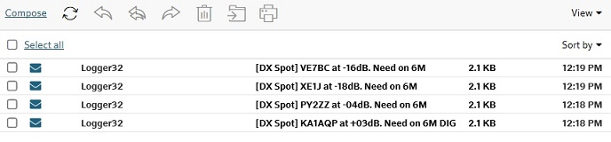

UBM_6AB1

### Sub menu for Logging options

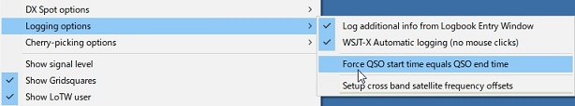

new UBM_6AC

The UDP Logging requests.txt file logs every QSO logging request received from the WSJT/JTDX UDP. This file is created in the \Logger32 directory and erased every time Logger32 starts.



UBM_6AD